**INTEGRATION OF EXCEL & SQL**

**KPI’S**

1.SELECT SUM(Sales_Amount) FROM sales_data;



2.SELECT SUM(Sales_Amount)/ COUNT(DISTINCT Quantity_Sold) AS AVG FROM sales_data;

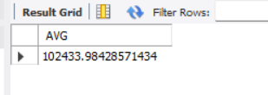

3.SELECT SUM(Quantity_Sold) AS Total_Product_Sold FROM sales_data;

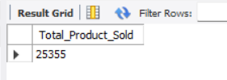

4.SELECT SUM(Unit_Cost) AS Total_Cost FROM sales_data;

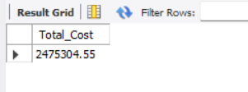

5.SELECT SUM(Unit_Price) AS Total_Price FROM sales_data;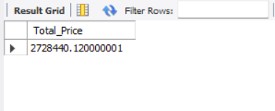

6.SELECT COUNT(Product_ID) AS Total_Products FROM sales_data;

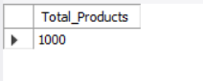

**CHART QUERY**

1. SELECT SUM(Sales_Amount), Product_Category FROM sales_data

GROUP BY Product_Category;

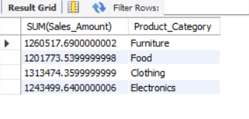

2. SELECT SUM(Sales_Amount), Payment_Method FROM sales_data

GROUP BY Payment_Method;

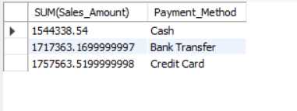

3. SELECT SUM(Sales_Amount), Payment_Method FROM sales_data

GROUP BY Payment_Method;

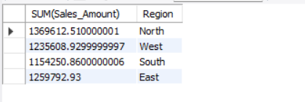

4. SELECT SUM(Discount), Region FROM sales_data

GROUP BY Region;

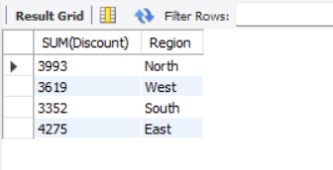

5. SELECT SUM(Sales_Amount), Sales_Channel FROM sales_data

GROUP BY Sales_Channel;

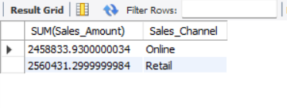

6. SELECT SUM(Quantity_Sold), Product_Category FROM sales_data

GROUP BY Product_Category;

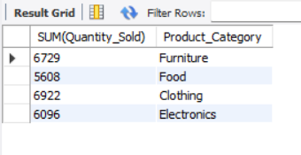

7. SELECT SUM(Quantity_Sold), Product_Category FROM sales_data

GROUP BY Product_Category;

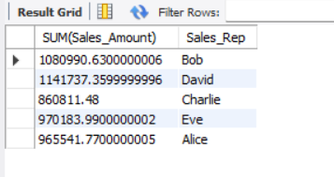

8. SELECT COUNT(Product_ID), Sales_Rep FROM sales_data

GROUP BY Sales_Rep;

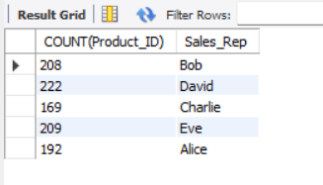

9. SELECT Sales_Rep, Payment_Method, SUM(Sales_Amount)

FROM sales_data

GROUP BY Sales_Rep, Payment_Method;

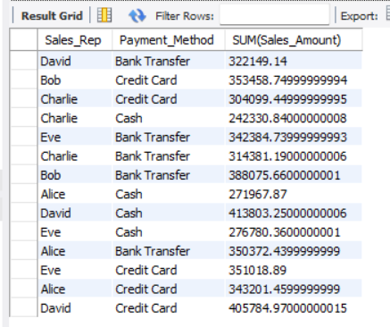

10. SELECT Sales_Rep, Product_Category, SUM(Unit_Price)

FROM sales_data

GROUP BY Sales_Rep, Product_Category;

